**Lab 1 – Successfully completed lab of Build your custom VPC**

**Created Costume VPC**

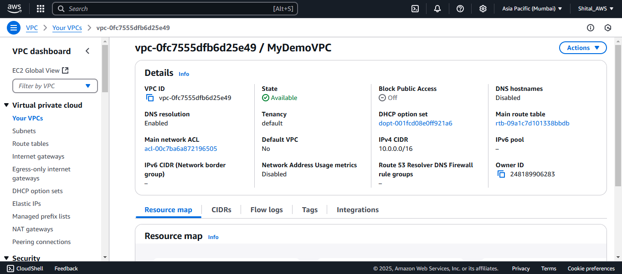**Enable DNS resolution and Enable DNS hostname**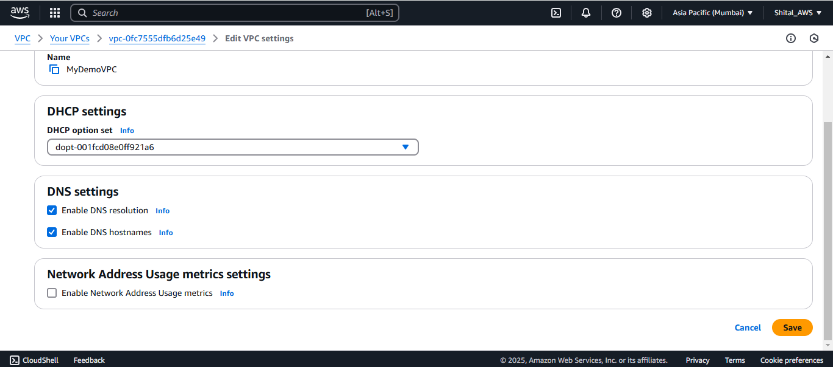

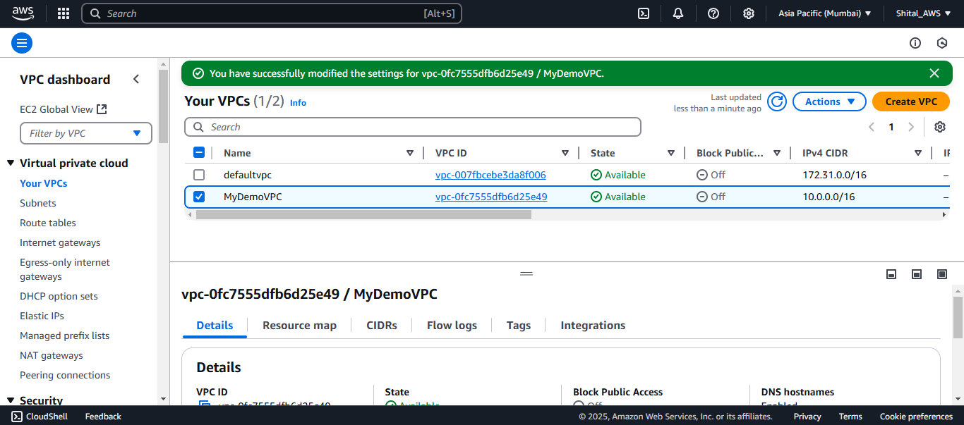

**Lab 2 – Successfully completed lab of Build your custom subnets.**

**Build costume public subnet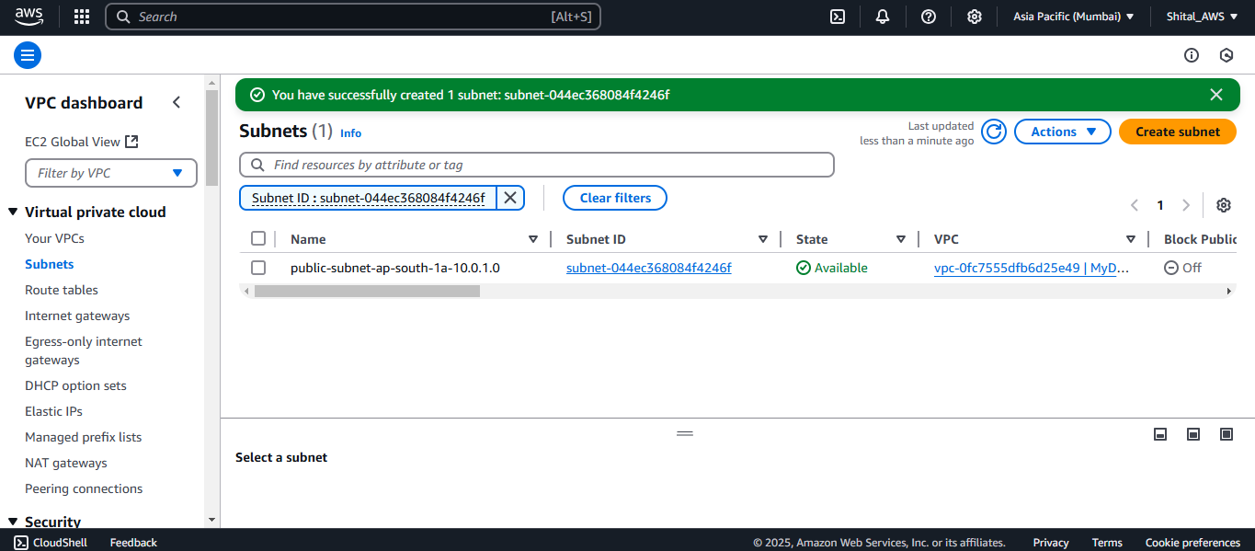Enabled Auto Assign IP setting**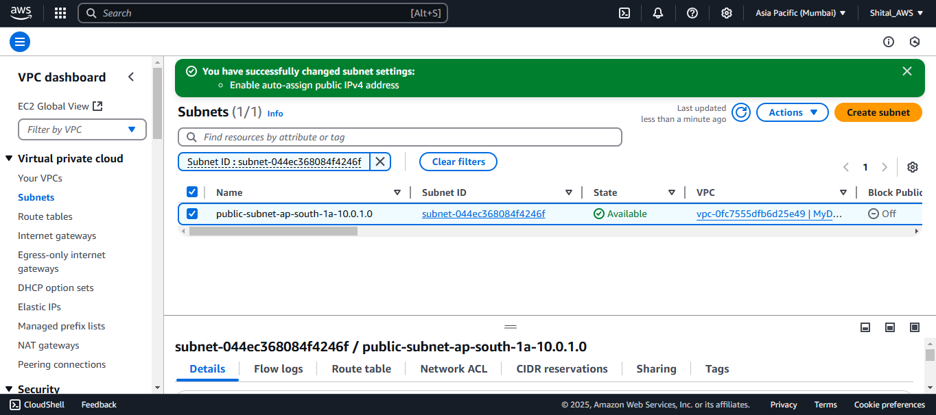

**Build costume private subnet**

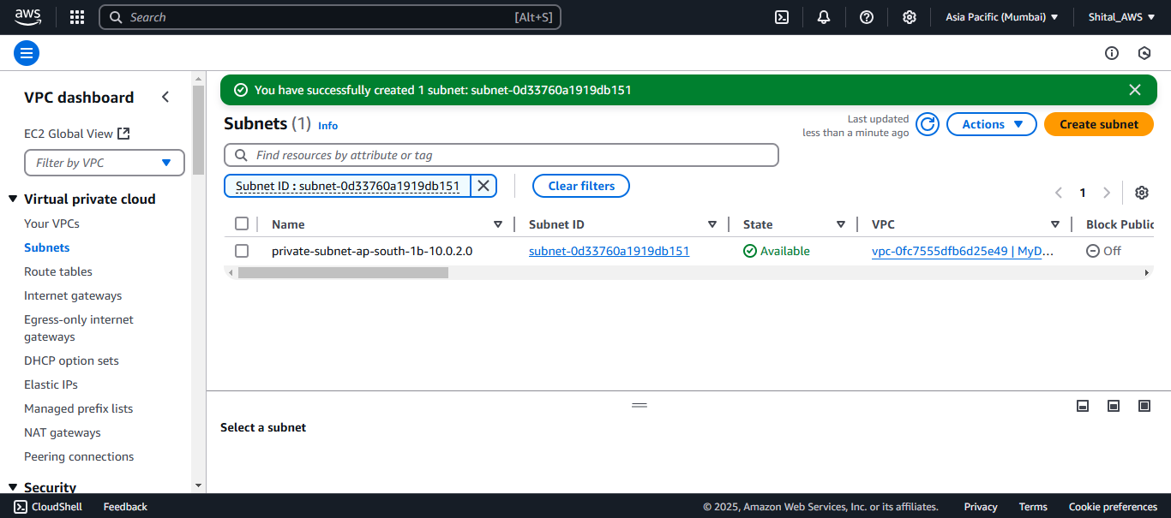

**Lab 3 - Successfully completed lab of** **Create Internet Gateway and attach to your custom VPC**

**Create Internet Gateway**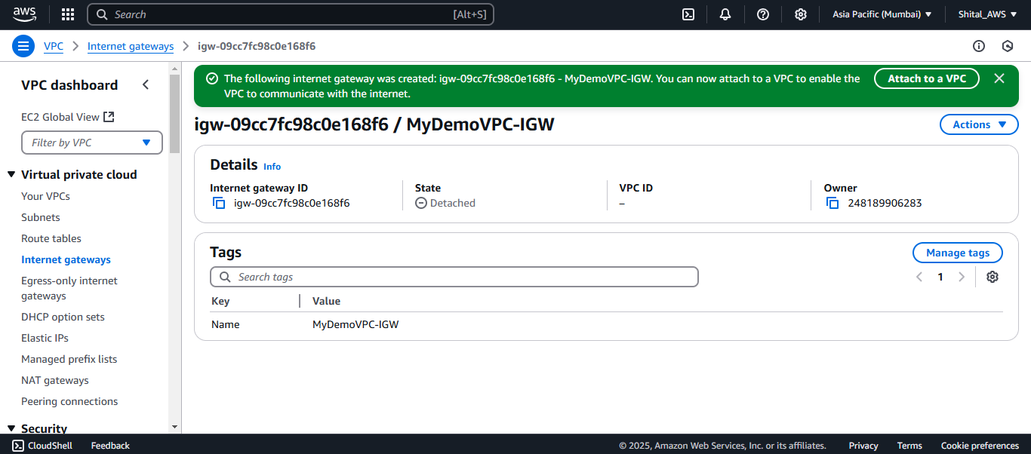

**attach to your custom VPC**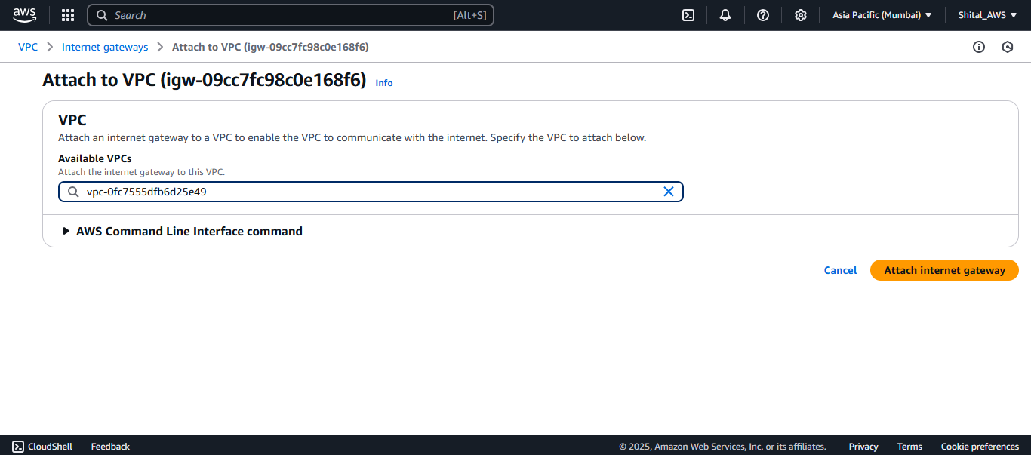

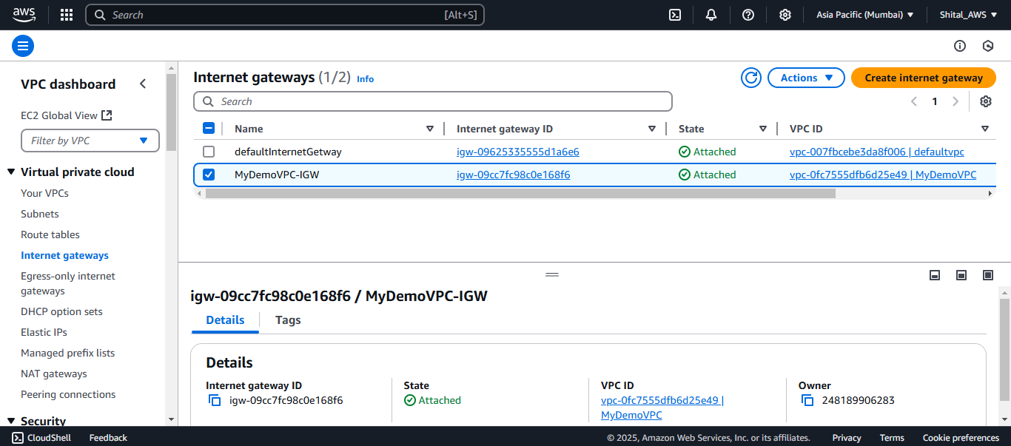

**Lab 4 - Successfully completed lab of Creating Route Tables**

**Created public route table**

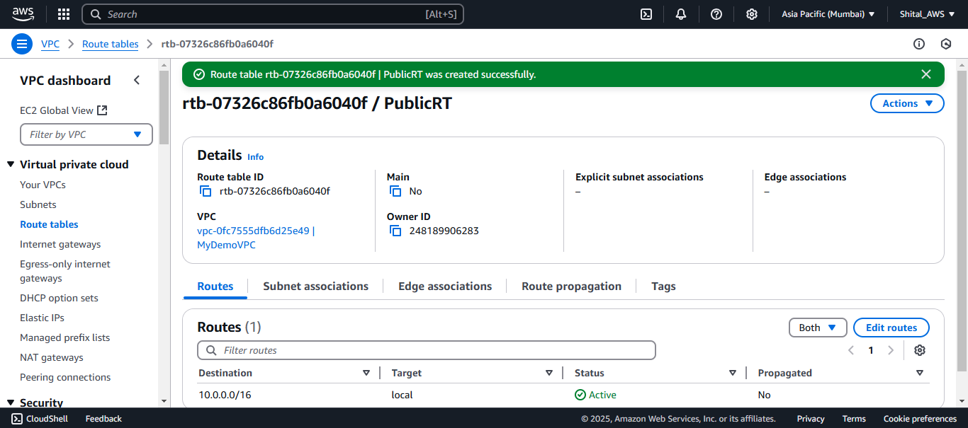

**Created private route table**

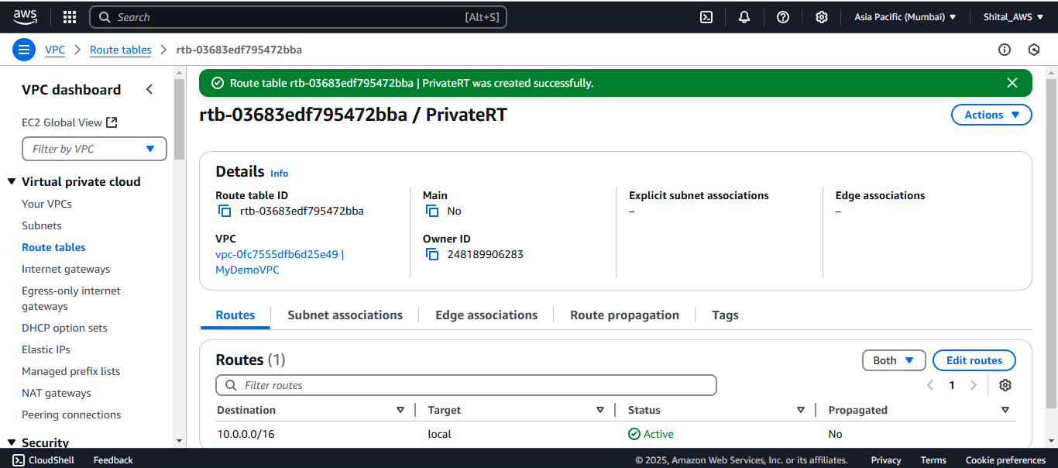

**Lab 5 – Successfully completed lab of Subnet Association with Route Tables**

**Edit Subnet Association Public route table**

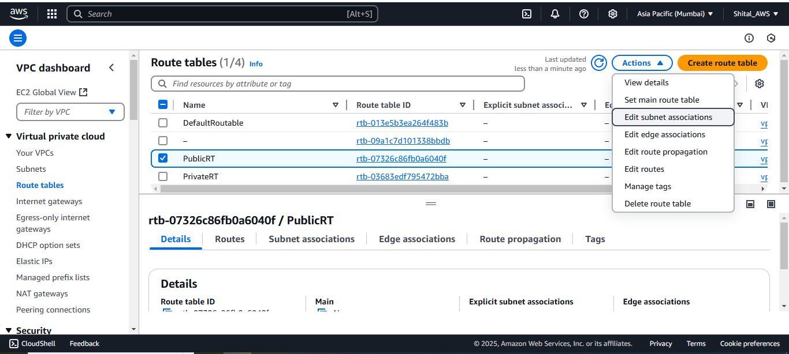

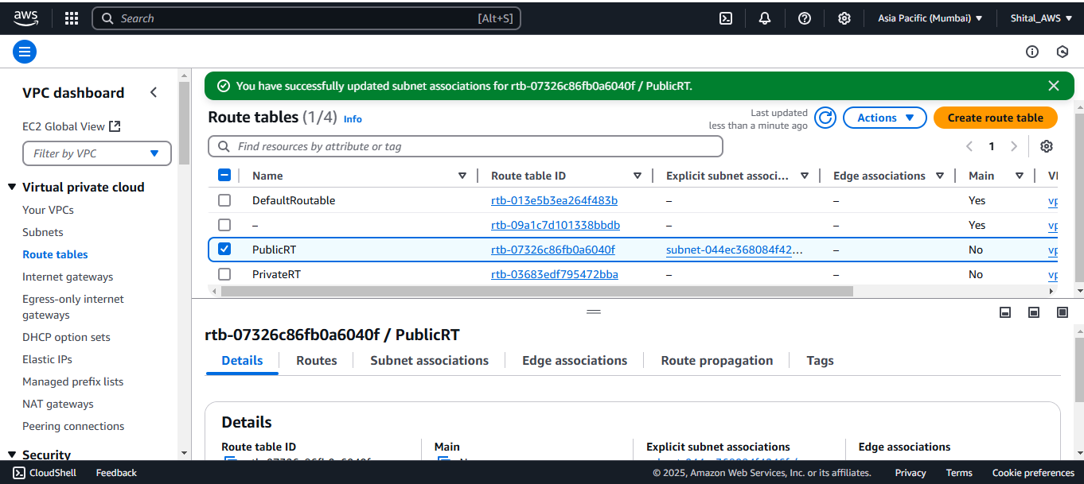

**Edit route for public route table only**

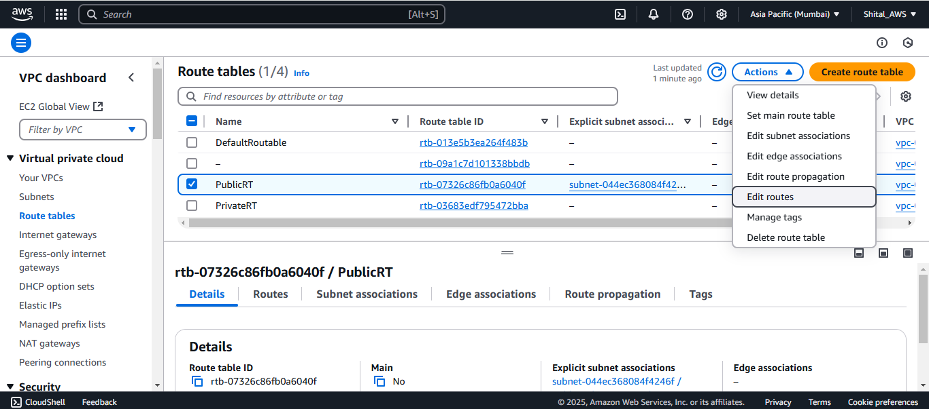

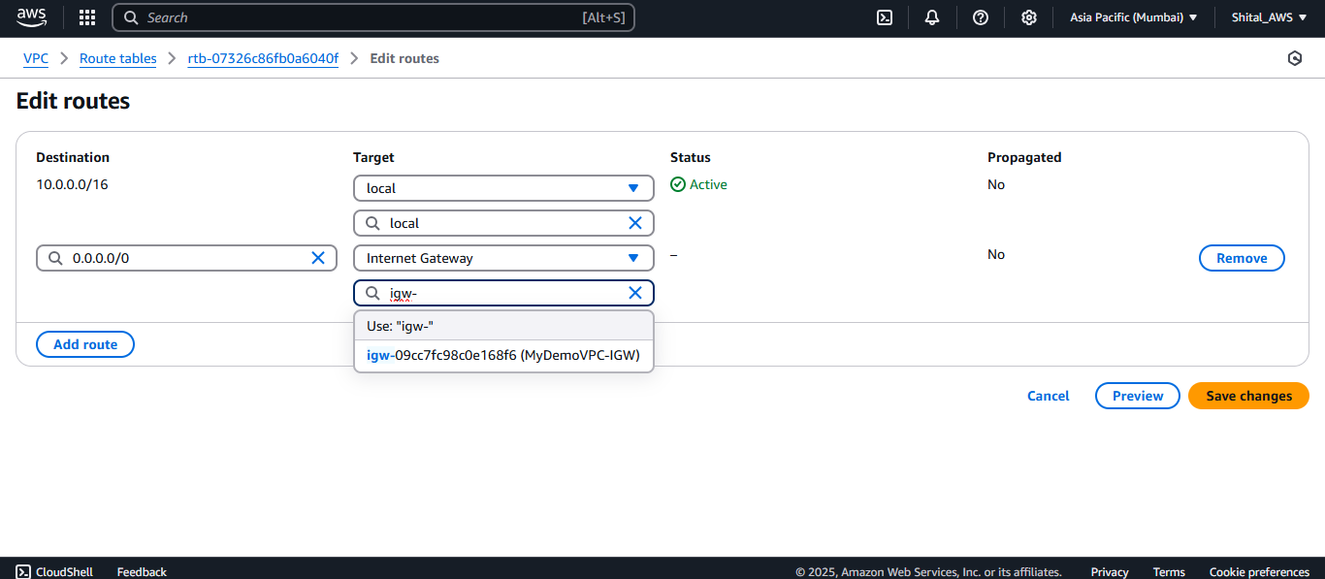

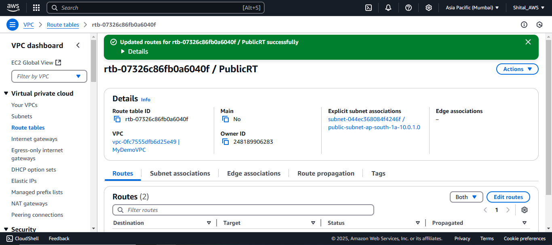

**Edit Subnet Association Private route table**

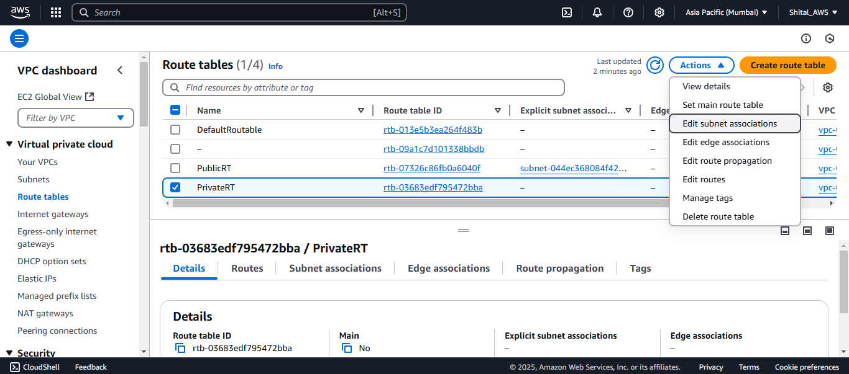

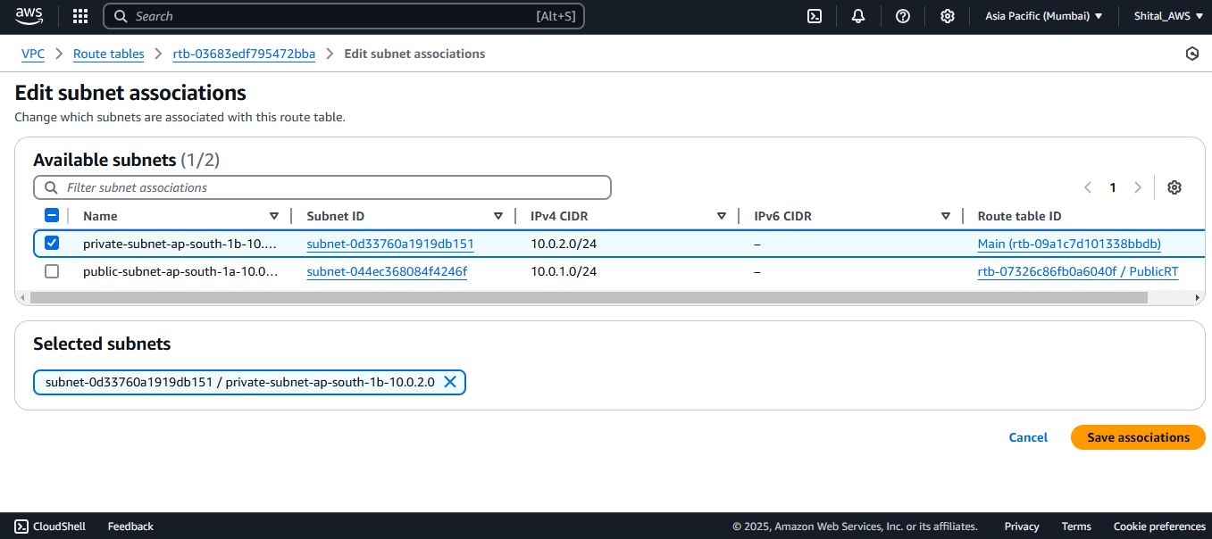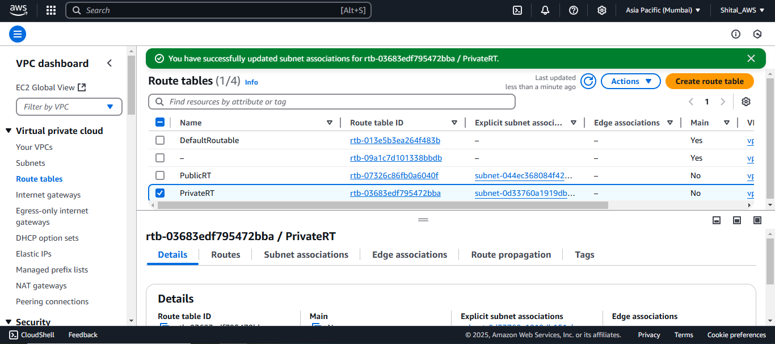

**Lab 6 - Successfully completed lab of Launch Web Server Instance in Public Subnet and DB Instance in Private and verify communication**

**Create 2 Ec2instace webserver and DBserver**

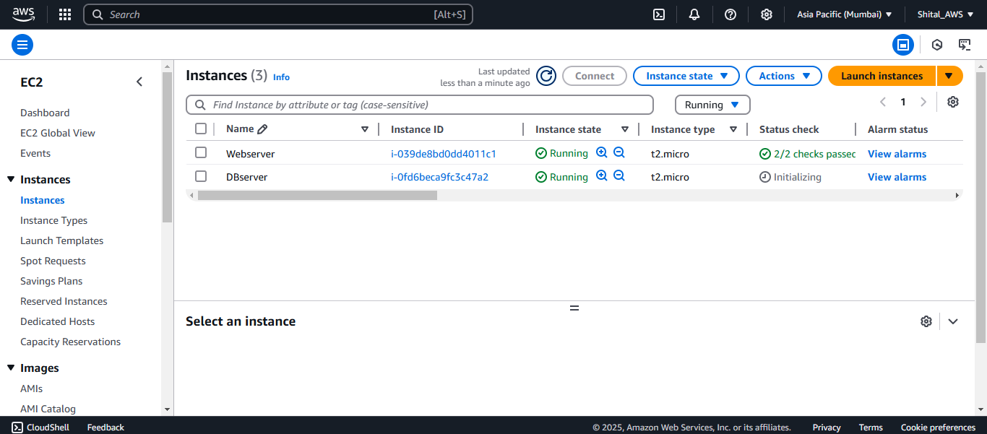

**Verify you are able to reach and access DB server instance from Web Server instance.**

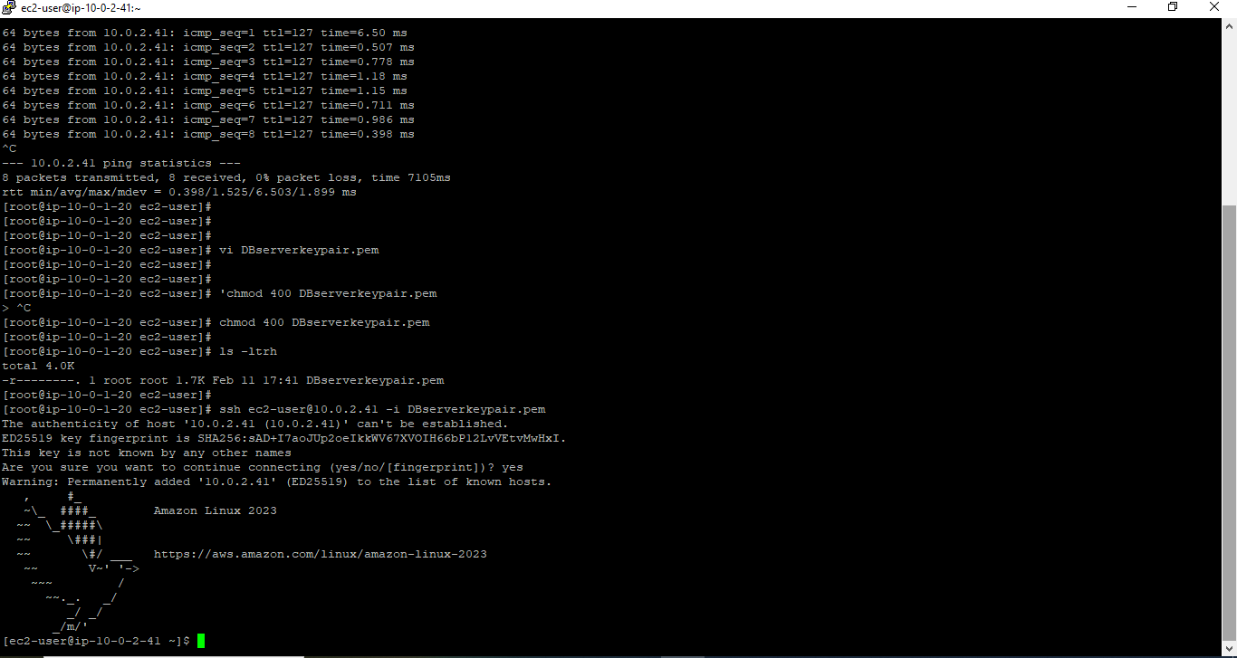

**Lab 7 – Successfully completed the lab of Configure NAT gateway to allow communication to private DB instance from external/Internet**

**Created NAT getaway**

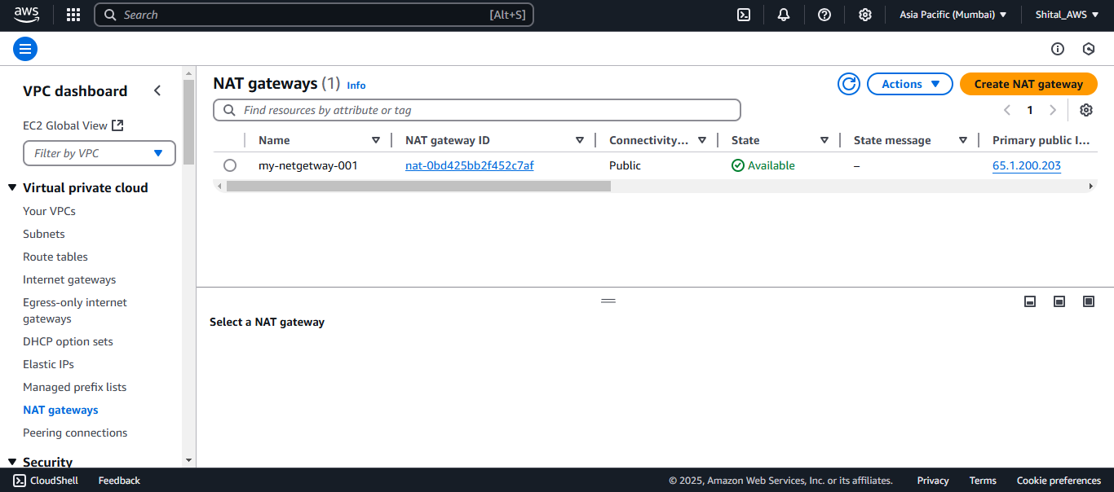

**Provide route to Nat getaway**

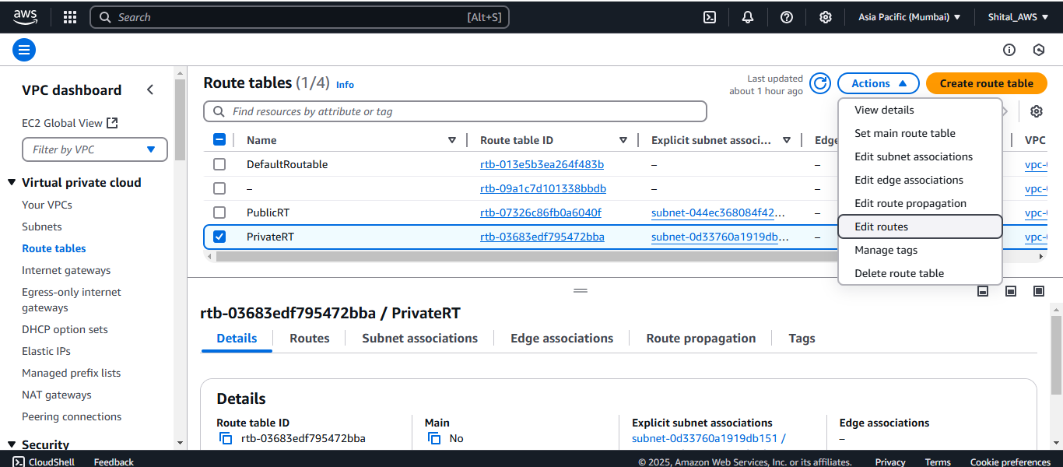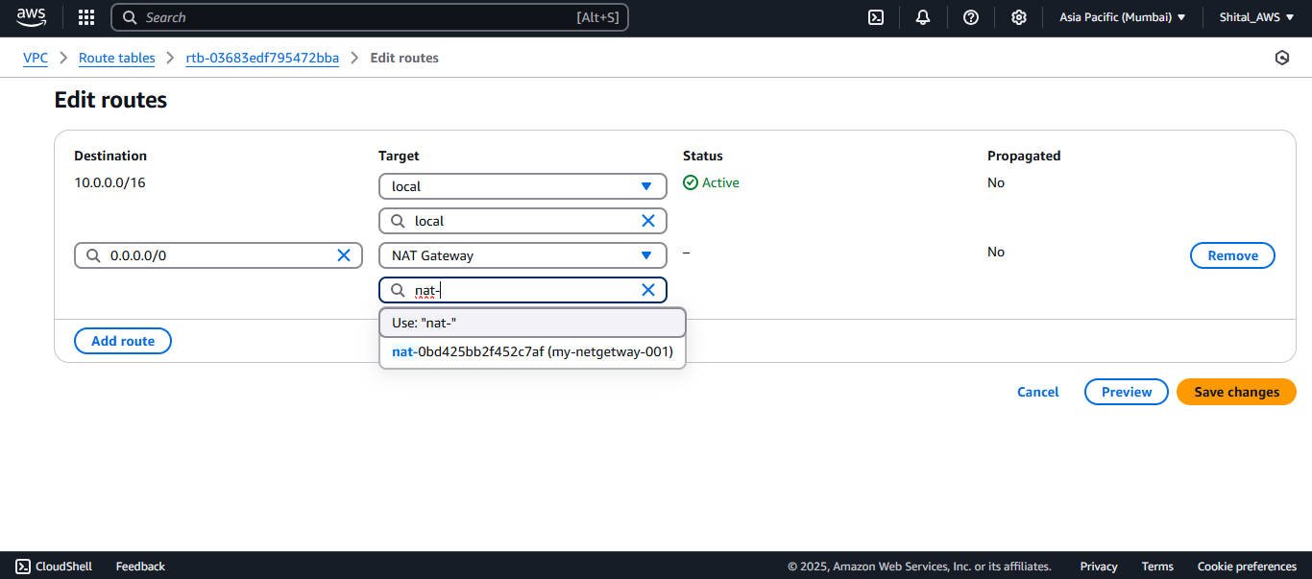

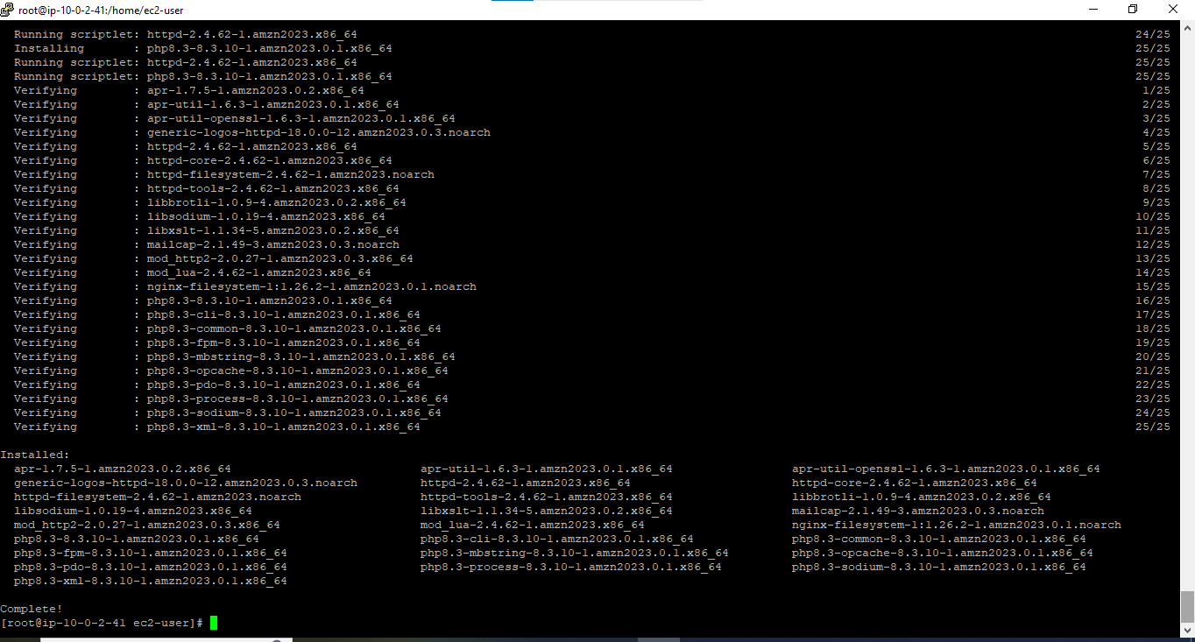

**Lab 9 - VPC Cleaning**

**Terminate the instances if exists**

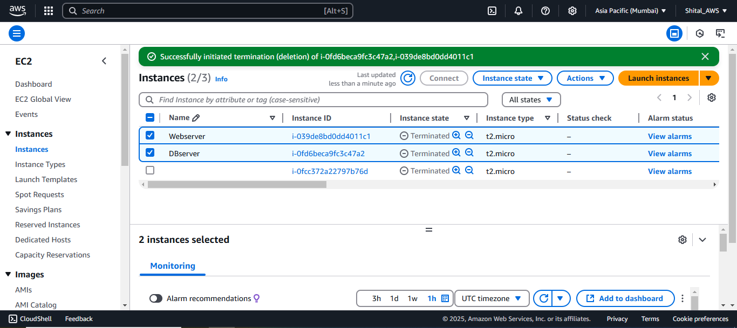

**Delete NAT gateway. It takes some time to delete**

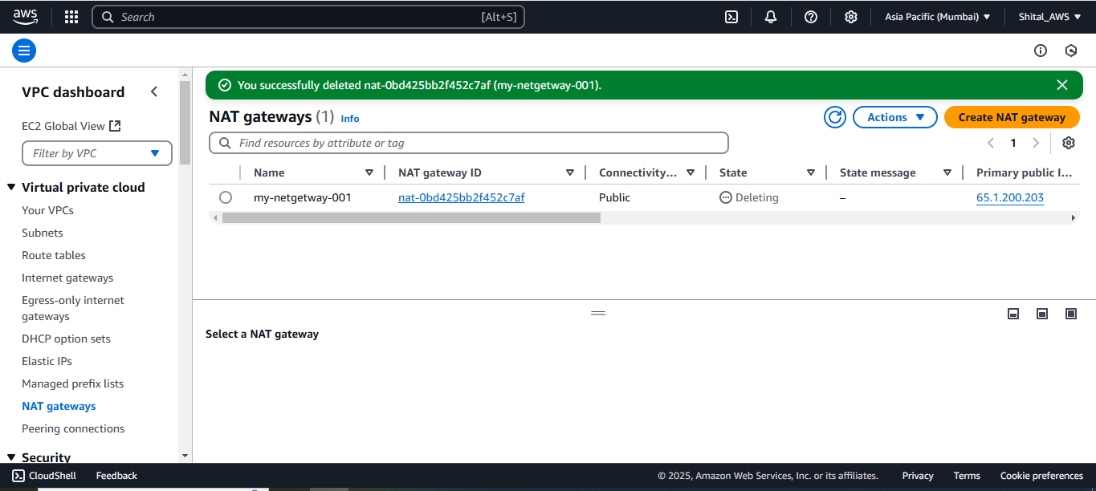

**Release the Elastic IP address if e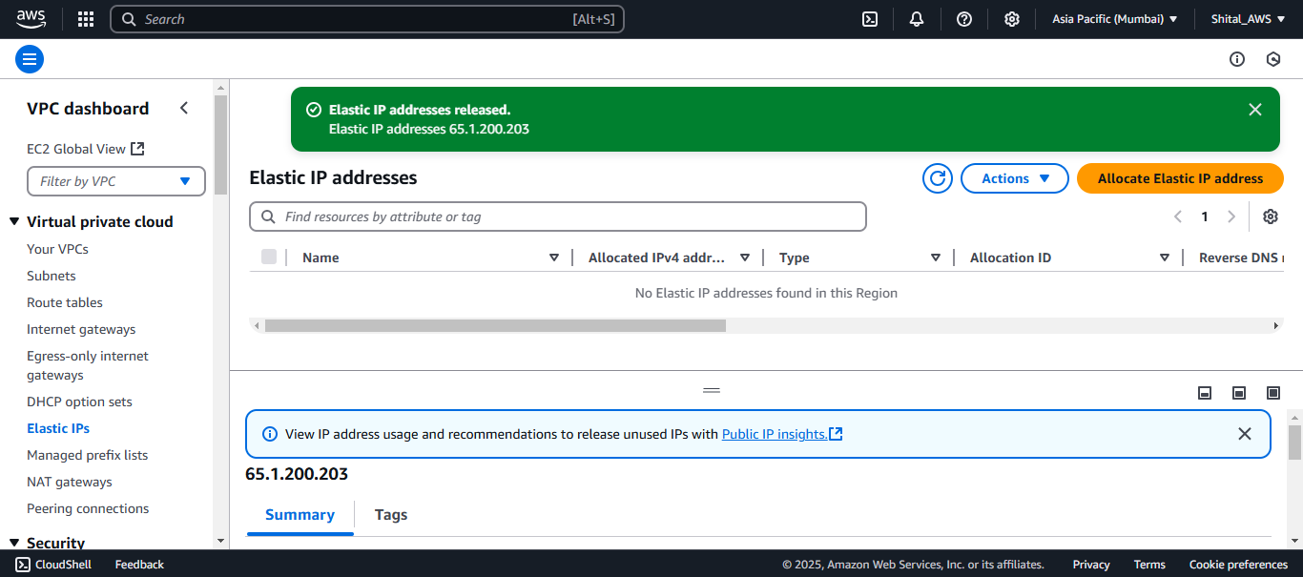xists.**

**Select your custom VPC -> Action -> Delete. It will delete all associated subnets, route tables, Network ACLs, Internet gateways etc.**

